

**Interaction and Usability  
(MOD002591)**

b4taking0

**Due Date: Turnitin, 2pm, Friday 04 May, 2018**

**Faculty: Science and Technology**

**Department: Computing & Technology**

**Module Code: MOD002591**

**Academic Year: 2017/8**

**Semester: 2**

**Content**

1. Introduction 2

2. Critical Exploration (15%) 2

3. User Needs Analysis (15%) 3

3.1 Persona 3

3.2 Scenario 3

3.3 Task Analysis 3

3.4 Environmental Analysis 3

4. Preliminary Design (10%) 4

5. Detailed Design (15%) 4

5.1 Decisions Relating to User Needs Analysis 4

5.2 Decisions Relating to Usability 4

5.3 Decisions relating to Cognitive Issues 4

6. Implementation (15%) 5

7 Evaluation (15%) 5

7.1 Cognitive Walkthrough 5

7.2 Heuristic Evaluation 5

8 Coherence 5

9 References 6

# 1. Introduction

In this document, I will present the process for the development of the UI designed for smartphones. This application/UI is designed to help people, as soon as they wake up, to be up-to-date and informed about 3 different topics: weather, traffic and news.

# 2. Critical Exploration (15%)

First, we have to know the difference between User Experience Design and UI design, as I think it’s essential. Lamprecht (2017) describes that UXD is focused on improving customer satisfaction and how loyal they are, through developing usability, how easy the UI is to use, and pleasure.   
Furthermore he explains that UI design is “… the look and feel, the presentation and interactivty of a product.”.

Hassenzahl (2010) describes experience as an integration of “…perception, action, motivation and cognition…”. So, how can we give the best user experience possible?

There are a number ways that allow this to be fulfilled. The first one was mentioned by Sethumadhavan (2013), which has expressed that there is evidence that through minimizing the scrolling of a user, it will automatically enhance the user interface. He says “…potentially because of their difficulty in integrating information regularly or because of disorientation during reading.”

In addition to this, Paul van Schaik (2017) said that subjective quality, meaning in terms of attractiveness and stimulation, is essential and makes it quality design. This can be achieved because the human has appeal needs and stimulation needs, which can be met through UI designs.

Moreover Alali (2016) proudly explains that consistency is key when it comes to designing UI’s. There has to be a conformity between the colours, the font, images, videos and every other detail that makes a UI consistent. This backs up what Paul van Schaik (2017) said about subjective quality, which means subjective quality and consistency comes hand in hand.

Furthermore, I want to make it clear some of the best practices for designing an interface, which will be simplified. Usability.gov (2017) lists that keeping the interface simple by evading UI elements that arent needed is essential.  
Users will feel comfortable through using elements that aren’t strange to them and consistency of certain elements will allow the user to learn and apply what they’ve learned to other parts of the website.  
By using colours and textures strategically, this will allow the attention to go towards an item, for example, we could make a button red(which red is a universal colour for bad) for a no, and a button for yes, which would be green(universal colour for good).   
  
Lastly, but not least, the UI has to communicate what’s happening to the user through message boxes. Sometimes the location, errors, actions, etc, will happen, and if the UI does not communicate this to the user, he/she will be confused and perhaps it will be put off from the UI.

All of the statements above, which make a small part of the critical exploration of interaction and usability, will help to enhance the UI that I will prepare for my assignment. (450 words)

# 3. User Needs Analysis (15%)

### 3.1 Persona

The persona that will be shown is based on a real life example.

|  |  |
| --- | --- |
| **Name** | **Olivia Greggs** |
| Occupation | Flight Attendant |
| Gender | Female |
| Status | Single, no children |
| Location | Bishops Stratford, London |
| Nationality | British |
| Education | A-Levels in English, Maths and Biology |
| Hobbies | Social media, reading news, sports |

|  |
| --- |
| **Biography** |
| Olivia is a 22 year old flight attendant, who loves social media and news, and spends most of her free time (such as morning and evening) browsing through Facebook, Instagram, The Independent and The Daily Mail. Most of the day she’s working, travelling by plane. She goes to work by car and comes back too by car. |  |

|  |  |
| --- | --- |
|  | **Most Frequently Used Technology** |
| Smart Phone | This is where Olivia performs her daily tasks such as texting work colleagues, and answering emails. In her smartphone she uses a variety of apps, such as Weather forecast, google maps, News app, etc. |
| Laptop | This is where Olivia’s work reports are done. She also uses laptop to watch Netflix along with checking out sports results. |

|  |
| --- |
| **Frustration and Pain Points** |
| * Olivia strives hard to save time during the morning as she takes a while to get ready and usually wakes up later than she’s supposed to. * Her phone lacks the memory to contain more apps, which leads into Olivia having to delete apps all the time to free up space, to fit in pictures/other apps she tries to install. * Her phone lacks speed when it comes to opening different apps, which result in frustration and sometimes even ending up not checking things she actually wants due to lack of time. * Olivia has been numerous times late to work due to traffic and traffic sometimes is caused because of the weather. * Olivia travels a lot due to the nature of her job, therefore she is often surprised with the weather condition of certain countries. |

|  |
| --- |
| **Persona Goals** |
| * Being able to effectively saving her time by simply opening one app and having all information she needs available to her * Not having to worry about not being able to take a picture on her phone or install new necessary apps due to lack of memory * Navigating easily through simple but informative interface * Being able to know the current situation on traffic so she can plan her trip to work * Being able to know the weather situation of the country she has travelled to. |

### 3.2 Scenario

Olivia starts her day off looking through her phone notifications, before doing anything else. She seems to have an order by which she opens her apps.

First she starts with Facebook, then Instagram, and then starts hovering through her other interest apps such as news, weather forecast for the day and current traffic situation. She realizes that she has wasted too much time on her phone because her phone kept freezing all the time whenever she opened a new app.

Sometimes phones freeze because their memory is too full. As Olivia finished getting ready, as soon as she is off the door to her car and starts driving, she realizes that she is tight on time whilst being stuck on traffic that she didn’t predict because her phone apps kept freezing which led on her giving up opening the traffic app.   
  
Her boss spoke to her about her being constantly late, and he recommended Olivia an app that does everything she requires. The app is small and it has all the information needed for Olivia to be up-to-date.

### 3.3 Hierarchical Task Analysis

This hierarchical represents the current tasks present in the current applications.

Checking all apps to be informed

0

Open Facebook

1

Open Weather Forecast app 5

Open Traffic app 4

4

Open News app

3

Open Instagram

2

Phone crashes

4.1

Phone crashes

5.1

Phone crashes

3.1

Close apps and try again 5.2

Close apps and try again 4.2

Close apps and try again 3.2

This hierarchical represents the application proposed for mobile

B4Taking0 app

0

Check Weather Forecast 5

Check Traffic

4

Check news

3

Log into user

2

Launch application 1

Enter username

2.2

Enter Password

2.1

### 3.4 Environmental Analysis

B4taking0 is an app that requires internet connection, either Wi-Fi or mobile data. It relies on updating 24/7 the constant data that lies within this app therefore internet connection is essential. Other factors such as audio will not be a problem as there is no audio in the app, so using it in any noise place will be fine. In addition, the app will have to present a clear and presentable UI, so it can be seen in any kind of weather or under any lighting.

# 4. Preliminary Design (10%)

The following design was made on “Justinmind Prototype” tool on desktop.

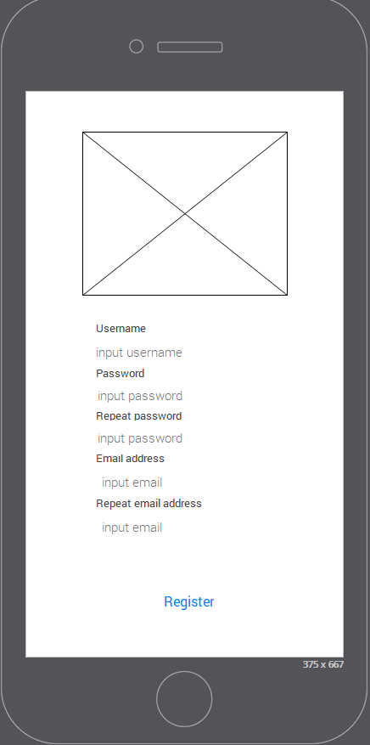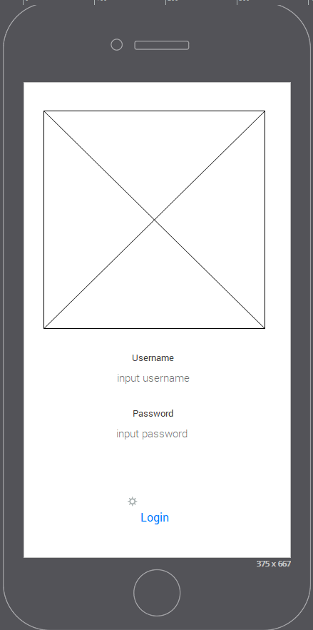

3

2

1

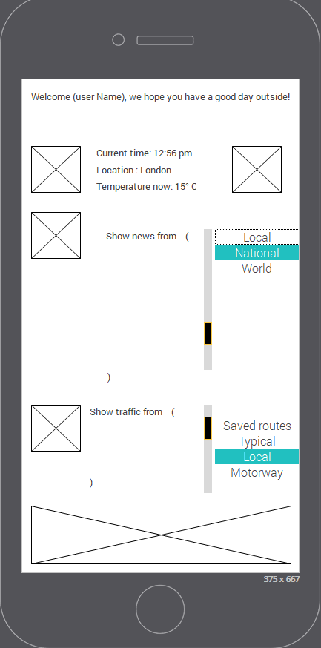

# 4.1 Narrative

Image 1 represents the login menu that the user is presented with. The first top part of the screen will be the logo picture of the App, which is why it’s been made in a big format. Afterwards, the Username and password would be typed below, and a login button right below. I decided to implement a Username and password simply because I would like to notify the phone user when a major change on either the news, or weather or traffic change. So we let the user know what’s going on. The Blue text will have the colour code for buttons.

Image 2 is the main menu screen, which has a few things to have in mind. All 3 pieces of information will be found on this screen. I have decided to make small areas for each piece of information simply because this app is meant to be for fast check-ups. A user should spend no longer than 2-3 minutes in this app. If I added extra screens and made bigger areas of information, the user might be distracted easily and spend more time in this app. There are also lists on news and traffic, so the user can easily choose the preference of bit of information he desires to know of, according to his needs.

Image 3 is the register menu, which will allow the user to register unto our platform for the purpose of getting updates from us into their emails, and allowing us to notify the user when an update is on its way.

Images are represented as grey boxes with an X in the middle.   
The image 2 bottom picture will be a hyperlink which will serve as a revenue income. It is possible to add ads in this app, so that the app is free for the user whilst at the same time earning some income from the app.

# 5. Detailed Design (15%)

### 5.1 Decisions Relating to User Needs Analysis

Olivia is a person that travels by car a lot, therefore I have designed the interface in a way that she can read information quick, in case she gets to the car and still has 1-2 minutes spare, so that she can “swallow” the information fast. This was done by designing 2-3 screens so that she can navigate through, and most informantion being found in 1 screen.

Furthermore, Olivia shows a lot of experience when it comes to technology. She uses on daily basis a laptop and her smartphone. This allows her to be more familiar with the many types of UI’s and their elements. Wong (2017) insinuates that ease of use means not forcing the user to learn new elements and representations for tasks the UI presents.

Due to the nature and purpose of the app, 99% of the times the users will read this information in a chill and calm environment. Therefore average sized font will be used so that most information can be squeezed in one screen.

### 5.2 Decisions Relating to Usability

An interface that has usability requires three main outcomes. Soegaard (2018) enumerates that first, the user should become familiar and „used to it“ in the first time he’s been in the website. I have designed the website so that it doesn’t require to click a lot of buttons in order to get to the place you want, and therefore, easy to become familiar with.

In addition to this, Soegaard also has said that it should be easy to recall the user interface, therefore a “good” design means the user will stick around for longer.

On top of this, I have added error message boxes which guide the user, in case he presses something by accident, so that he can be informed and use the app correctly.

### 5.3 Decisions relating to Cognitive Issues

A lot of mobile apps have very small interaction such as small buttons, small images, which might lead to user frustration due to the fact that the button has been clicked 10 times. This problem can be tackled with average/big fonts, images and buttons. This will allow the user to only have to click once on buttons, and not have to locate the phone closer than it should be, in order to read what is being transmitted in the app.

Whitenton (2013) describes humans like computers when it comes to processing a certain amount of information. Like the computer, the human brain has a limited amount of processing power and when the amout of information is trespassed, the ability to handle this gets harder. Therefore, I designed my app so that the amount of information that is being read doesn’t exceed a certain amount of time, and that way the cognitive side of our brain doesn’t suffer.

# 6. Implementation (15%)

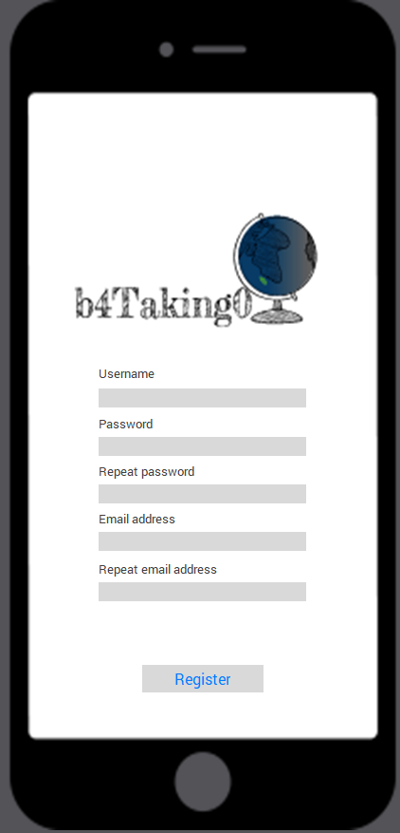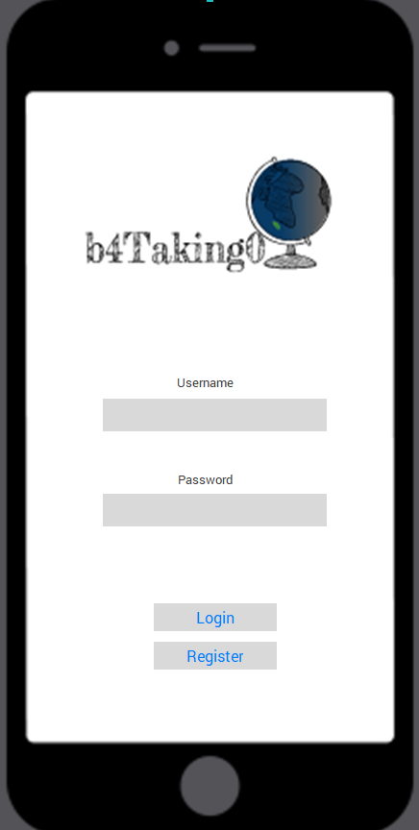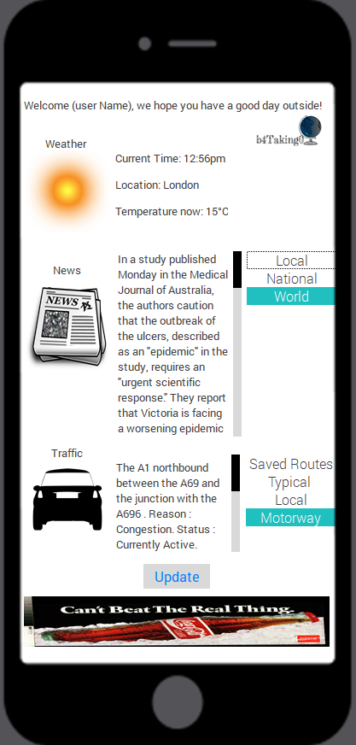

If any of the user input boxes are empty, and the user clicks” login” or “register”, an error box will prompt:

Error: Please input the (datafield.Missing) that is missing.

OK

When the user clicks “update” a message box will show saying:

UPDATED!

OK

When the user clicks “Register” on the RegisterMenu, it will prompt a message box saying:

Thank you for registering with us.

OK

# 7 Evaluation (15%)

### 7.1 Cognitive Walkthrough

Below there will be listed questions that are found on Dix et al.’s(2005,p.43).

|  |  |  |  |  |  |  |
| --- | --- | --- | --- | --- | --- | --- |
|  | **User Action** | **System Response** | **“Is the effect of the action the same as the user’s goal at that point?** | **“Will users see that the action is available?”** | **“Once users have found the correct action, will they know it is the one they need?”** | **“After the action is taken, will users understand the feedback they get?”** |
| 1 | The user presses “Register” button | User is taken into screen RegisterMenu | Yes | Yes | Yes | Yes |
| 2 | The user clicks “Login” after entering their username and password | User is taken into MainMenu with the informations | Yes | Yes | Yes | Yes |
| 3 | A messagebox is prompted when an action happens | User has to click ok | Yes | Yes | Yes | Yes |
| 4 | The user presses “Register”button after inputting his details. | Messagebox prompted saying “Thank you for registering with us” | Yes | Yes | Yes | Yes |
| 5 | User clicks on the drop box button “Local” in newspaper | Updates the paragraph box with local news | Yes | Yes | Yes | Depends on the users interest or English level. |
| 6 | User clicks on the ad | System takes the user to the ad page | Depends if he clicked by accident on the ad or it was intended | Yes | Yes | Probably not, as I said, a lot of people click on the ad by accident, so they might not know they clicked on it and be confused. |

### 7.2 Heuristic Evaluation

The following evaluation of the UI is using the Nilsen Norman Group, (1995) version checklist.

1. Consistency & Standard

Throughout my UI, I tried to keep the colours, the font, the image styles, and the sizes of everything and the elements in general consistent according to the “theme” I was using. I decided to stick with the White and grey theme because they are basic colours and often pleasant to the eye for every type of person.

1. Flexibility and efficiency of use

One screen that contains all the information they need is efficient and quick. The simple and easy to learn UI makes it very efficient to use.

1. Error prevention

Whenever a user performs an action, I made sure the user knew what was happening, to let him know of updates on the app, or errors that happened whilst navigating through it.

1. Aesthetic and minimalist design

I kept my UI clean and free from unnecessary elements. I kept the colours smooth and consistent and I tried to minimize over loading of text and elements in general on each screen.

1. Visibility of System status

When users read throughout the page, they are aware of what kind of things they have to do.

1. Match between system and real world

My system uses words that are understood by the user, such as “Newspaper, Weather, etc”. No system-oriented terms were displayed to the user.

1. User control and Freedom

I allowed my users to go back unto the loginpage by simply clicking the “logo” icon.

1. Recognition rather than recall

I labelled my images in the main menu so that the user would know the icons meanings.

1. Help and documentation

My UI did not require any help as it is very simple and straight forward to work with. Nonetheless, in the future I will integrate a button that contains steps on how to work with the app, the future updates, and documentation.

1. Help users recognise, diagnose and recover from errors

Error messages are displayed in plain English and easy to understand what to do next.

# 9 References

# References

Alali, A. M. A. S. H., 2016. Graphical User Interface Features In Building. *European Scientific Journal,* 12(15), pp. 332-336.

Hassenzahl, M., 2010. *The Encyclopedia of Human-Computer Interaction.* 2nd Ed ed. unkown: Interaction Design Foundation.

Lamprecht, E., 2017. *The Difference Between UX and UI Design - A Layman’s Guide.* [Online]   
Available at: https://careerfoundry.com/en/blog/ux-design/the-difference-between-ux-and-ui-design-a-laymans-guide/  
[Accessed 17 4 2018].

Paul van Schaik, M. U. D. E. M. L. A. M., 2017. User-experience in design and use: enhancing the experience of media content with programmable surround lighting. *SpringerLink.*

Sethumadhavan, A., 2013. Principles for Designing Good User Interfaces. *research digest,* na(na), p. 33.

Soegaard, M., 2018. *Usability: A part of the User Experience.* [Online]   
Available at: https://www.interaction-design.org/literature/article/usability-a-part-of-the-user-experience  
[Accessed 17 4 2018].

usability.gov, 2017. *User Interface Design Basics.* [Online]   
Available at: https://www.usability.gov/what-and-why/user-interface-design.html  
[Accessed 17 4 2018].

Whitenton, K., 2013. *Minimize Cognitive Load to Maximize Usability.* [Online]   
Available at: https://www.nngroup.com/articles/minimize-cognitive-load/  
[Accessed 17 4 2018].

Wong, E., 2017. *Principle of Consistency and Standards in User Interface Design.* [Online]   
Available at: https://www.interaction-design.org/literature/article/principle-of-consistency-and-standards-in-user-interface-design  
[Accessed 17 4 2018].

Dix, A., Finlay, J., Abowd, G.A. and Beale, R., 2005.

Human Computer Interaction. [pdf]

Available at: http://link.springer.com/referenceworkentry/10.1007%2F978-0-387-39940-

9_192 [Accessed 06 April]. http://dx.doi.org/10.1007/978-0-387-39940-9_192.

Nielsen Norman Group, 1995.

10 Usability Heuristics for User Interface Design

. [online]

Available at: https://www.nngroup.com/articles/ten-usability-heuristics/ [Accessed 06 April,

2017].